1. Create a DB table which will be used as a selection method for elementary search help.

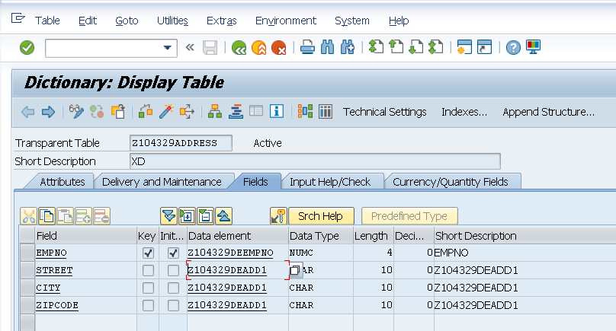

Note: Create separate data elements for Street, City and Code. Give appropriate Field Labels.

1. Add few records in the DB table

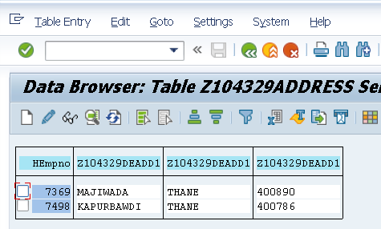

1. Create an Elementary search help in SE11.

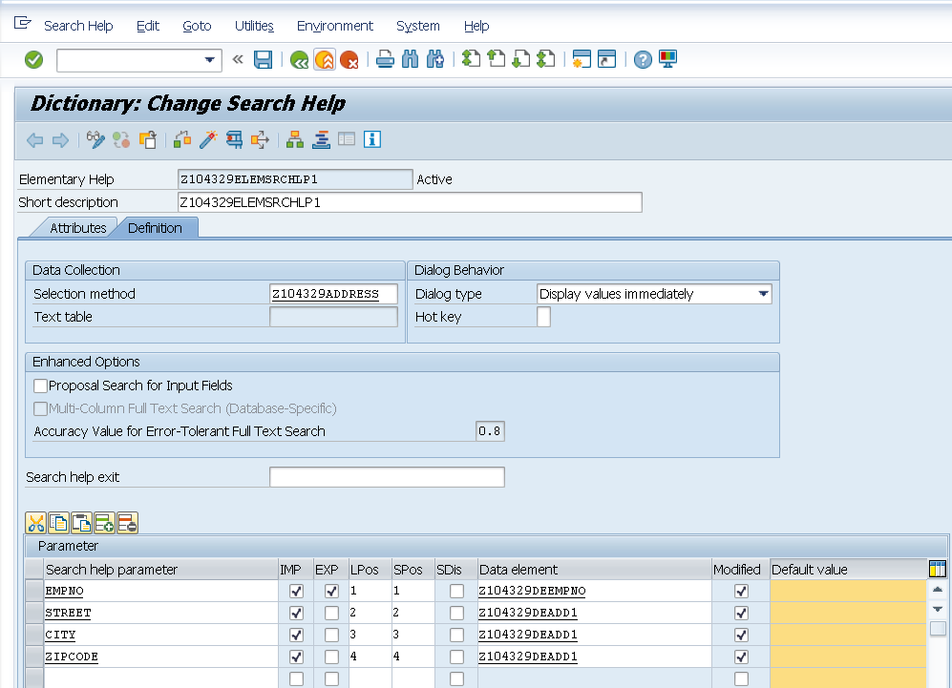

1. Test the search help.

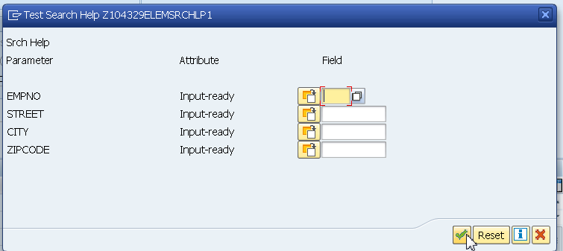

1. Note the Import parameters.

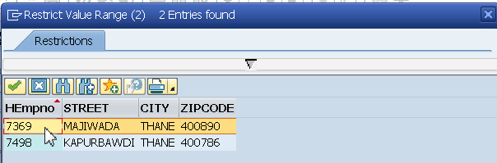

1. Note the Export Parameter.

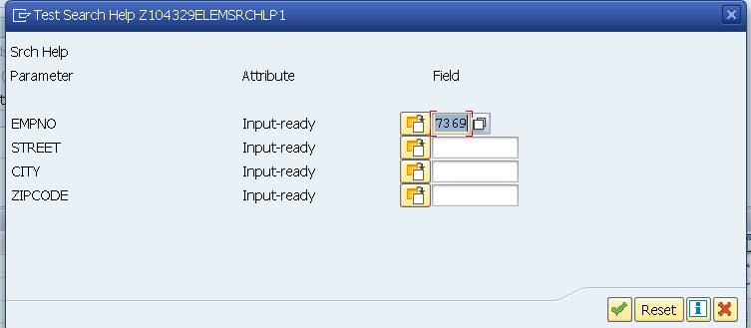

1. Attach the elementary search help to the DB table. (Another DB table)

In this case search help is attached to Empno field.

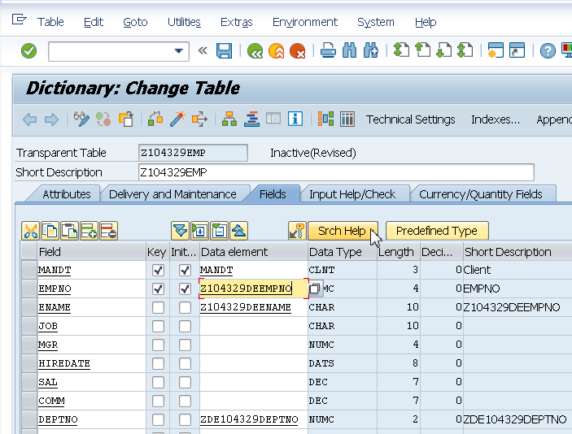

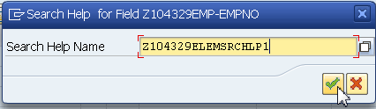

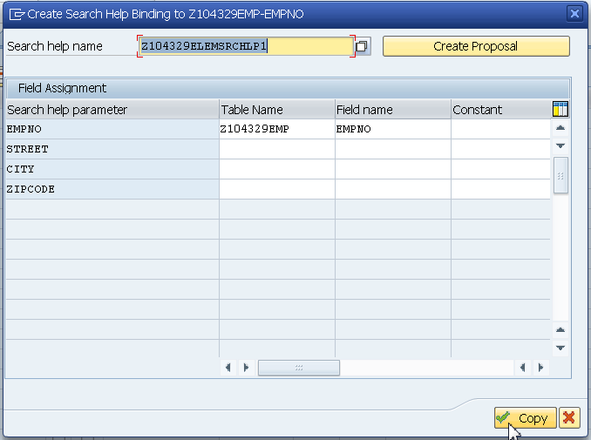

1. Create entries in the DB table.

Observe search help while adding records in the Empno field of the Emp table.